Reno County 4-H
Apparel Approval Form

The purpose of this form is for the 4-H Club or Group to have their apparel design approved before printing to ensure the proper use of the 4-H clover and co-wordmark.

Attach the number of pages needed for the apparel design. Please print in color.

Please allow 10 business days for the design to be reviewed. If edits need to be made, the individual listed below is the one who will be contacted.

4-H Club apparel will need to have one of the following wordmarks (in color, black & white, black, or white). Email Adam to receive the electronic version of the wordmark.
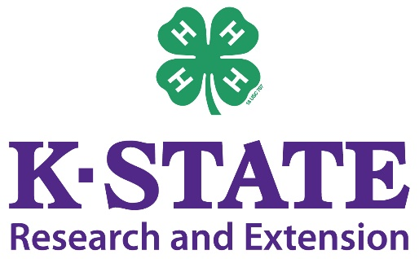

Return this form and any necessary attachments to the extension office, or submit electronically by emailing Adam at alesser@ksu.edu

4-H Club/Group: ____________________________________ Date: ________________

Contact Person: ____________________________________ Cell #: ___________________________

Email Address: _____________________________________

Be sure to include any additional information or details to be considered.
K-State Research and Extension is an equal opportunity employer and provider.

